

To: Full Council

Date: 17th December 2012

Report of: Head of City Development

Title of Report: Barton Area Action Plan: Inspector’s Report

Summary and Recommendations

Purpose of report: To propose the adoption of the Barton Area Action Plan

Key decision? No

Executive lead member: Councillor Colin Cook

Policy Framework: The contribution of new housing from the Land at Barton and associated regeneration are fundamental to achieving the objectives of the Council's Corporate Plan (meeting housing need) and the Oxford Sustainable Community Strategy (affordable housing). The adoption of the AAP will fulfil a key element of the Local Development Scheme and builds on the strategic policies set out in the Oxford Core Strategy.

Recommendation(s): Council is asked to:

1: note the conclusions and recommendations of the Inspector’s Report on the examination into the Barton Area Action Plan
2: adopt the Barton Area Action Plan as part of Oxford’s Local Plan
3: endorse the AAP’s associated documents as part of the AAP adoption (including the Sustainability Appraisal and Habitats Regulations Assessment Adoption Statement and Equalities Impact Assessment)

Introduction

- The Core Strategy allocates 'Land at Barton' as a strategic housing site. This site is a once in a generation opportunity to provide large numbers of new homes and associated facilities as a vibrant new community that forms part of the city. The development also offers the opportunity to extend the benefits to existing neighbouring communities in the form of access to the new facilities and services and better links to the rest of the City and the surrounding countryside. The site is being brought forward through an Area Action Plan (AAP) that will form part of the Oxford Local Plan.

Inspector’s Report

- The AAP was submitted to the Secretary of State in April 2012. An independent planning inspector, Dr Shelagh Bussey, was appointed to carry out the examination. Hearing sessions were held in July and September 2012. The Inspector’s Report was received on 14th November 2012, and was subsequently published on the Council’s website. Prior to the receipt of the final report, the City Council was sent a draft report for fact-checking on 2nd November 2012. The Inspector’s Report can be viewed on the City Council’s website: www.oxford.gov.uk/bartonaap.

- The Inspector found that the Barton AAP provides an appropriate basis for the planning of development in that part of the city. She decided that there is good prospect that the infrastructure requirements and the development requirements of the AAP can be funded and delivered at the appropriate time.

- The Inspector identified a limited number of modifications needed to meet legal and statutory requirements and ensure that the plan is sound. Appendix 1 to this report consists of a table of the Inspector’s modifications. The changes recommended in the Inspector’s Report are based on proposals put forward by the City Council in response to points raised and suggestions discussed during the Examination.

- Subject to the changes identified by the Inspector, she concluded that the Barton AAP satisfies the requirements of section 20(5) of the Planning and Compulsory Purchase Act 2004 and meets the criteria for soundness in the National Planning Policy Framework.

Summary of Inspector’s Changes

- The Main Modifications put forward by the Inspector (Appendix 1) can be summarised as follows:
  - Inclusion of policy MP1 that makes a presumption in favour of sustainable development;
  - Inclusion of supporting text to clarify the approach towards development proposals in the Old Headington Conservation Area that fall within the AAP boundary;
  - Revised wording for Policies BA1 and BA7; and their supporting texts;
  - Inclusion of Annex 3 – Housing Trajectory; and:
  - Revisions to Maps 1 and 6.

- Council’s attention is directed in particular to the Main Modifications which deal with Policies BA1 (The ring-road), and BA7 (Pedestrian and cycle links). In brief the Inspector said that she generally agreed that it was important that the development of this strategic site does not result in a new community that is isolated, but that she felt she had not seen enough evidence to feel comfortable with two aspects of the policies, namely the requirement for a 40mph speed limit (and houses facing the A40), and the provision of standalone surface-level pedestrian crossings, (in addition to the new junction), particularly given the County Council’s concerns. The Inspector felt that making these aspects requirements of policy went beyond the evidence that was available and she requested that the City Council propose some amendments to the policies to address these concerns. As such, tracked changes to the policies were produced, assessed through the Sustainability Appraisal process, consulted upon (between 27th July and 7th September 2012) and discussed at Special Council on 20th September. The Inspector has recommended that these changes be made to the plan in order that it can be found sound. These changes mean that the plan now provides for a reduced traffic speed on the A40 (although not at the 40mph level) and no surface-level crossings on the A40 other than that included in the new access junction (although other types of crossings would be permitted).

- Although not part of the submitted AAP, the proposals by Ruskin College for development of their fields to the south of the A40 were discussed in detail at the examination. The Inspector concluded that for a range of reasons (including impact on the conservation area and access issues) that “allocation of land at Ruskin Fields would be inappropriate and unjustified, and would therefore be unsound”.

- The Inspector also found that in terms of processes, the Duty to Co-operate has been met; the Sustainability Appraisal process is “demonstrably robust” and that “the Council has clearly put significant and innovative effort into engaging the local and wider communities, and hard to reach groups”.

Adoption of the Barton Area Action Plan

- The Localism Act 2011 made a number of changes to the rules concerning adoption of plans including what was stated to be a change from binding Inspector’s Reports to non-binding Inspector’s Reports. The Inspector’s Report concludes that the AAP should not be adopted as submitted, but could be made sound and capable of adoption by inclusion of the main modifications. This means that the Council can adopt the AAP subject to the recommended main modifications and with additional modifications that cumulatively do not materially affect the AAP’s policies (as altered by the main modifications). The Council remains unable to adopt the AAP other than in a form that is recommended by the Inspector in all material respects. Appendix 2 provides further advice from Legal Services on this matter.

- Officers would strongly recommend that Council adopts the AAP. It is the product of several years’ work and a robust evidence base. The Inspector considered the strategy in detail and found it to be soundly based. An adopted AAP will provide the certainty to proceed with much-needed housing and regeneration. If the AAP were not to be adopted, this would put at risk the key development project at Barton.

The AAP document and Policies Map

- The Barton AAP has now been updated to include the Inspector’s changes. Minor factual and grammatical corrections have been made where errors have been spotted. Appendix 3 to this report shows the final version of the document.

- The adopted Barton AAP will be accompanied by an updated Policies Map (formerly called the Proposals Map) setting out the spatial policy designations that flow from the AAP’s policies. Appended to this report (Appendix 4) is an extract of the updated Policies Map. The Policies Map will also be updated as a result of the Sites and Housing Plan. The Inspector’s Report on the Sites and Housing Plan is expected in the New Year. Following this, the Policies Map will be fully updated and published in the large format.

Use of the Barton AAP in decision making

- Once adopted by Council, the Barton AAP will form part of the statutory development plan for the purposes of section 38(6) of the Planning and Compulsory Purchase Act 2004. This means that it will have full weight in determining planning applications.

- Once adopted the Barton AAP, together with the adopted Core Strategy, adopted West End Area Action Plan and ‘saved’ Local Plan policies, will form the Oxford Local Plan (a new title introduced through the National Planning Policy Framework).

Associated documents

- Several associated documents have been produced alongside the AAP in support of its policies and proposals. For example a Habitat Regulations Assessment has been produced and a Sustainability Appraisal has been carried out in phases throughout the AAP process. A “Sustainability Appraisal and Habitats Regulations Assessment Adoption Statement” has been produced to summarise these processes; this statement is available to view on the website: www.oxford.gov.uk/bartonaap. An Equalities Impact Assessment has been carried out for the Barton AAP. The Equalities Impact Assessment is available on the City Council’s website at CD1.17 on the website: www.oxford.gov.uk/bartonaapexamination.

- Council is asked to consider and endorse the Barton AAP’s associated documents as part of the AAP adoption process.

Level of risk

- On adoption of the Barton AAP, any person aggrieved may make an application to the High Court to legally challenge the plan; the implications of this are discussed at paragraph 21 below. There is a risk associated with choosing not to adopt the AAP as outlined in paragraph 11 above. A risk assessment has been undertaken and the risk register is attached (Appendix 5). All risks have been mitigated to an acceptable level.

Climate change and environmental impact

- The Barton AAP objectives seek to encourage a low carbon lifestyle by: encouraging people to walk, cycle and use public transport; providing new homes and buildings that use energy and water efficiently; and, by making effective use of renewable and low-carbon energy. The Sustainability Appraisal has considered the effects of the AAP policies on climate change and the environment. Overall, the policies are considered to have a beneficial impact on climate change.

Equalities impact

- A key theme of the Barton AAP is regeneration. Regeneration can help to tackle disparities in life chances by transforming deprived areas and improving the lives of those living in and around them. The Equalities Impact Assessment shows that the policies and proposals in the Barton AAP will help address existing inequalities by increasing the availability of affordable housing, adding to the range of community and educational facilities and by linking local people to economic opportunities. There is no evidence that there will be significant negative impacts.

Financial implications

- The costs associated with the production of the Barton AAP have been met through the current resources of the Planning Policy team and budget. The AAP has a strong emphasis on deliverability and the policies reflect evidence on viability.

Legal Implications

- On adoption of the Barton AAP, the City Council is required to publish a notice of adoption stating that any person aggrieved may make an application under section 113 of the Planning and Compulsory Purchase Act 2004 to the High Court on the grounds that the document is not within the appropriate powers and/or a procedural requirement has not been complied with. Any such application must be made within six weeks starting with the date of adoption. The High Court may quash the plan wholly, or in part, if it is satisfied that the plan is to any extent outside the appropriate power, and/or that the interests of the applicant have been substantially prejudiced by a failure to comply with a procedural requirement.

- Officers consider that the relevant statutory procedures have been met during the preparation of the Barton AAP. The examination was conducted by an experienced planning inspector and the AAP was endorsed by Council prior to the recommencement of the hearing sessions in September 2012. The level of risk of a successful legal challenge is considered to be acceptably low.

Name and contact details of author:-
Name: Rachel Williams
Job title: Principal Planning Officer
Service Area / Department: City Development
Tel: 01865 252170 e-mail: rwilliams@oxford.gov.uk

List of appendices:
Appendix 1 - Table of the Inspectors’ Main Modifications
Appendix 2 - Legal Services advice on status of Inspector’s Report
Appendix 3 - Final version of the Barton AAP
Appendix 4 - Extract of the updated Policies Map
Appendix 5 - Risk assessment
Appendix 1 – Table of the Inspector’s Main Modifications:

Main Modific-ation | Policy/  Page  /Para | Detail of Main Modification
MM1 | Spatial Vision 2.5 | Insert new text:  “National Planning Policy Framework  Policies in Local Plans should follow the approach of the presumption in favour of sustainable development so that it is clear that development which is sustainable can be approved without delay. All plans should be based upon and reflect the presumption in favour of sustainable development, with clear policies that will guide how the presumption should be applied locally.”  Insert new policy:  Policy MP1:  When considering development proposals the Council will take a positive approach that reflects the presumption in favour of sustainable development contained in the National Planning Policy Framework. It will work proactively with applicants jointly to find solutions which mean that applications for sustainable development can be approved where possible, and to secure development that improves the economic, social and environmental conditions in the area.  Planning applications that accord with Oxford’s Local Plan* (and, where relevant, with neighbourhood plans) will be approved without delay, unless material considerations indicate otherwise.  Where there are no policies relevant to the application or relevant policies are out of date at the time of making the decision then the Council will grant permission unless material considerations indicate otherwise, and unless:  - Any adverse impacts of granting permission would significantly and demonstrably outweigh the benefits, when assessed against the policies in the National Planning Policy Framework taken as a whole; or  - Specific policies in that Framework indicate that development should be restricted.  *Oxford’s Local Plan comprises of the Core Strategy, West End Area Action Plan, saved policies from the Oxford Local Plan 2001-2016. When this Plan and the Sites and Housing Plan are adopted they will form part of Oxford’s Local Plan.
MM2 | Map 1 and Map 6 | Amend Map 1:  - To show boundary of Strategic Site  - Amend description of dark green line on Key to read ‘Existing pedestrian and/or cycle ways’ and reduce the length of the arrows  - Delete arrows used to depict ‘Access to countryside’  - Correct depiction of link through centre of site (past substation) from a lime green dotted line, to a dark green line as it is an existing pedestrian and/or cycle way.  - Reposition existing footpath along northern boundary of site  - Amend key to read “possible pedestrian and cycle crossing” at Stoke Place  - Remove the small purple arrows from the purple lines “potential frontages” parallel to the A40  See new Map 1 appended to this schedule  As a consequence of above changes, amend Map 6:  - Amend description of dark green line on Key to read ‘Existing pedestrian and/or cycle ways’ and reduce the length of the arrows  - Correct depiction of link through centre of site (past substation) from a lime green dotted line, to a dark green line as it is an existing pedestrian and/or cycle way.  - Reposition existing footpath along northern boundary of site  - Amend key to read “possible pedestrian and cycle crossing” at Stoke Place
MM3 | New para. after 4.1 | Insert new paragraph:  “This Area Action Plan does not allocate any sites within the Old Headington Conservation Area for development. Any development proposals that come forward within the conservation area would have to demonstrate to the City Council that the statutory requirement to preserve or enhance the conservation area would be satisfied. The City Council will take the same approach when considering any development proposals in the Old Headington Conservation Area as it would in conservation areas elsewhere in the city. Any such proposals will be assessed against the relevant policies of Oxford’s Local Plan particularly policy CS18 of the Core Strategy and saved policies of the Oxford Local Plan 2001-2016; in addition the Conservation Area Appraisal would be a material consideration.”
MM4 | BA1  Contents  2.2  5.11  7.19  9.5  Annex 5 | Amend Policy and supporting text:  “Section 5 Integration with surrounding areas and the rest of Oxford  It is important that the new neighbourhood feels part of Oxford.  The place-shaping policies in this Plan aim to foster the sense of community that will be generated by people living in the new and existing homes. There could be changes to Tthe A40 ring-road to improve the overall environment such as the provision ofwill be transformed to reduce the sense of segregation it currently creates.into a street that runs through the city rather than dividing it. There will be excellent high quality new links across/over the ring-road for pedestrians and cyclists, and improved public transport links. The local centre and community facilities will be easily accessible and new homes will be well related to existing homes in Barton. The City Council will work closely with the Highway Authority in pursuit of these aims.  Transforming tThe A40 ring-road  5.1 The A40 ring-road runs immediately to the south of the strategic development site, forming part of the strategic highway network. Our policy for this stretch of the ring-road is importantcrucial to achieving the Plan's wider vision and objectives.  5.2 Comprising dual carriageway with a maximum speed of 70 mph, the ring-road creates a sense of severance and isolation. It forms a noisy barrier physically separating the strategic development site from communities in Northway, Headington and the rest of Oxford. Leaving this stretch of the ring-road as it is would make it much harder to integrate old and new. Change would offer opportunities to:  - reduce noise levels for existing communities  - make best use of land, by increasing the amount of land available for development  - improve connectivity.  5.3 The ring-road will be Our aspiration is to change the ring-road to reduce noise, make it more physically attractive and help integrate development with the wider urban fabric.transformed the ring-road to ensure it is no longer a noisy and visually dominating physical barrier that separates Barton and its surroundings from the rest of the city. This will be We will seek to achieved this in the following three ways:  - Reducing tTraffic speeds will be reduced to a maximum of 40 mph.  Lower traffic speeds will reduce noise levels for the new development as well as for those living in surrounding communities. The amount of developable land wouldwill be increased by allowing development to take place closer to the ring-road. The lower speeds wouldwill allow traffic management measures in the form of a new signal-controlled junction or roundabout on the A40 ring-road and multiple safe and easy-to-use crossings for pedestrians and cyclists. Physical measures to the A40 to slow down traffic could also include changes to lane widths, the use of surface materials, street furniture and signage. Together Tthese measures wouldwill help to transform the look, feel and operation of this stretch of the ring-road.  - Building new development facing the ring-road  New developmentresidential frontages will could be built adjacent to the northern side of the ring-road. To avoid any sense of separation between the new neighbourhood and the rest of Oxford, new homes will be built facingfrontingonto the ring-road. There will be In such cases a parallel road would allowing access to the properties adjacent to the ring-road. These frontages of new homes will be along the southern edge of the strategic development site (though not necessarily its entire length) and in Barton itself. as shown in Iillustrations 1 and 2 show how proposed development could facefrontonto the ring-road on the strategic development site.  - Landscaping  The landscaping of the central reservation along this stretch of the ring-road couldwill be reviewedre-landscaped. The central reservation is well planted with mature vegetation. This forms another physical – albeit green – barrier between the strategic development site and the rest of Oxford. The planting couldshould be managed reviewedre-landscaped to support integrationbe more in keeping with a street running through the city. Any changes to the physical layout of the A40 and/or its speed limit will require the prior approval of the County Council as the Local Highway Authority.  5.4 The changes to the ring-road must consider the setting of the Old Headington Conservation Area, which lies to the south of the ring-road.  Policy BA1: Transforming the ring-road  In order to secure a reduction in traffic speeds, traffic management and safety measures will be put in place and design principles applied to the A40 ring-road between the western approach to the new junction/roundabout and the Headington roundabout.  Innovative solutions to the form and layout of development will be sought to facilitate integration and secure good quality living conditions, especially adjacent to the A40 ring-road. There may be an opportunity to provide homes adjacent to the northern side of the ring-road; however such development must not be accessed directly from the ring-road  Development on the strategic site must be set behind a buffer to the A40 ring-road. This should include a combination of landscaping, open space, pedestrian/cycle ways and a service road and informal car parking where appropriate.  The landscaping of the central reservation and either side of the ring-road should be managed in order to facilitate safe movement and access for all modes of travel.  Where relevant, any development adjacent to the ring-road and any changes to the existing landscaping must consider views into and out of the Old Headington Conservation Area.  Consequential changes:  Amend contents:  “Section 5 Integration with surrounding areas  15 – Transforming tThe A40 ring-road”  Amend paragraph 2.2:  “It will be integrated with the neighbouring communities. The stretch of the ring-road between a new junction and the Headington Roundabout will change in character. Lower speeds and less traffic noise could will allow development to front onto adjacent to the ring-road, reducing its visual dominance and the sense of separation. New development adjacent tofronting the ring-road, Barton Village Road, key open spaces…”  Amend paragraph 5.11:  “This is to help ensure integration by allowing new residential development alongside Barton and potentially the creation of dwellings adjacent to frontages along the ring-road to help transform it into a street.”  Amend paragraph 7.19:  “To help ensure that the linear park along Bayswater Brook is safe, attractive and well used, it should be fronted by residential development with views over the countryside. There should also be residential frontages onto the allotments and Barton Village Road and potentially homes adjacent to the northern side of the ring-road. The security arrangements for the existing allotments should be reviewed to ensure the right balance of security, accessibility and design.”  Amend paragraph 9.5:  “The new approach to the ring-road, with lower traffic speeds and consequently less traffic noise, will reduce the sense of severance between Barton and the rest of the city. Pedestrian and cycle crossings will be easier, and new homes in Barton could will front onto be located adjacent to the ring-road, facing the city, so the residents feel part of it.”  Annex 5 - Delete indicator and target:  “Transforming the ring-road – Traffic Speeds between the western approach to the new junction/roundabout and Headington roundabout - Maximum permitted traffic speed to 40 mph”
MM5 | BA2 | Additional wording at end of policy:  ‘To minimise disruption to sports provision the groundworks needed to re-configure the recreation ground should take place in the off-season.’
MM6 | BA7 | Amend Policy and supporting text:  “Pedestrian and cycle links  5.31 The ring-road currently imposes a significant barrier for pedestrians and cyclists, with only one existing grade-separated (differing levels) crossing point – a subway to the south of Barton, which provides a link to Headington.  5.32 To improve integration and permeability and to promote maximum usage, a network of safe and easy-to-use pedestrian and cycle routes along desire lines (the routes people are likely to take, with or without a formally designated path) is needed to connect the new homes with facilities in the new neighbourhood and link the new development to its surroundings in Barton, Headington, Northway and the countryside beyond Oxford, and to the rest of the city. There will be multiple safe and convenient pedestrian and cycle crossing links across/over points on the ring-road.  5.33 The existing footpath that runs south-northnorth-south across the strategic development site (and then beyond into the countryside in South Oxfordshire) couldwill be re-connected with Stoke Place linking the footpath with the public bridleway and byway that continues south into Old Headington along Stoke Place. AThe re-connected link wouldwill provide the new development with a direct pedestrian and cycle route to the shops and other facilities in Headington, the John Radcliffe Hospital and Cheney Secondary School. It wouldwill open up access to the countryside in South Oxfordshire for those living in Headington. Stoke Place wouldwill need to be upgraded to an appropriate standard, with changes to the surface, thinning of trees and vegetation and installation of sensitive street lighting. The nature of the changes to Stoke Place, together with the design, and siting and type of crossing, should respect the character of Old Headington Conservation Area.  5.34 The new vehicle junction or roundabout on the ring-road will include pedestrian and cyclist crossing phasing and facilities. The new development is an opportunity to improve the existing crossing to the south of Barton. This could be in the form of further improvements to the subway or a parallel surface-level crossing. There could be at least one other new pedestrian and cycle link overcrossing of the ring-road. linking the strategic development site with its surroundings. One potential locationcrossing point is from the new development to Foxwell Drive in Northway which would provide direct access to the wider cycle network and the city centre. Map 6 shows how the strategic development site will be accessed by vehicles, pedestrians and cyclists.”  Policy BA7: Pedestrian and cycle links  New direct, safe and attractive cycle and pedestrian links will be provided as part of the strategic development, including:  - re-connecting Stoke Place bridleway with the existing footpath running north-south across the strategic development site  - upgrading Stoke Place to an appropriate standard for a cycle route and footpath and in a manner that is sensitive to Stoke Place's role and character in the Old Headington Conservation Area  - a crossing of the A40 ring-road included in the new junction or roundabout  - enhancement of the existing crossing between Barton and Headington  - links between the new development and existing rights of way in the surrounding countryside  - giving priority to walking and cycling routes in the development, including connections to key destinations such as the local centre, community hub and Barton and the links across the A40 ring-road  - a street network that is designed to be fully cycle and pedestrian friendly.  There may be an opportunity to re-connect Stoke Place bridleway with the existing footpath running north-south across the strategic development site. Any link would need to ensure safety for all users. It would require the upgrading of Stoke Place to an appropriate standard for a cycle route and footpath in a manner that is sensitive to Stoke Place's role and character in the Old Headington Conservation Area.
MM7 | BA13 3rd bullet point | Additional wording at end of 3rd bullet point:  “The development’s scale, form, character and design must respect the site’s topography, natural features and setting of the site, including the impact on the Old Headington Conservation Area and its setting.”
MM8 | New Annex | Addition:  Annex 3 - Housing Trajectory.  See new appended to this schedule

MM2: New Map 1 and associated key

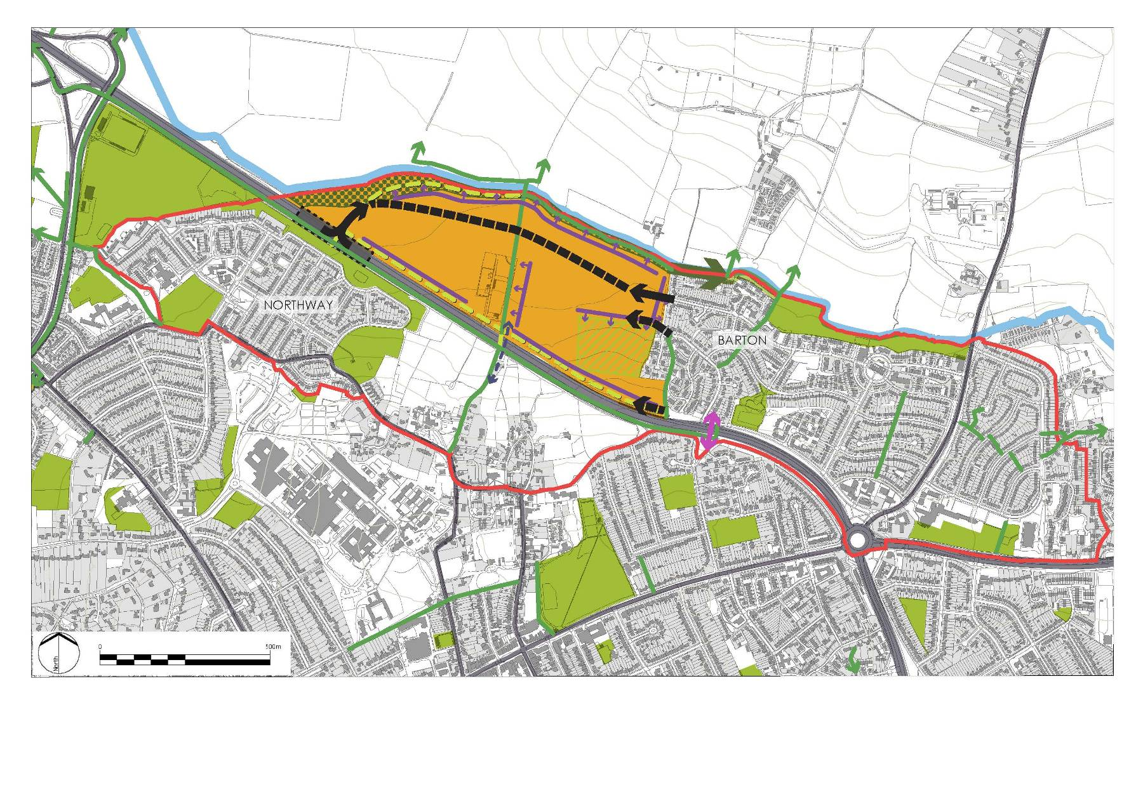

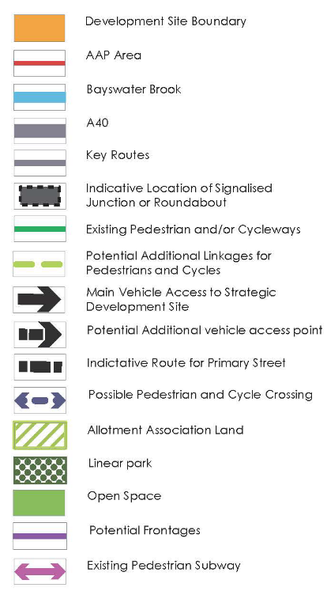
MM6 – New Annex

Annex 3 - Housing Trajectory

The housing trajectory demonstrates the position based upon the Strategic Housing Land Availability Assessment (Dec 2011) with the addition of sites proposed to be allocated in the Sites and Housing Plan. Barton falls within years 2014/15 and 2019/20. No allowance has been made for windfalls.

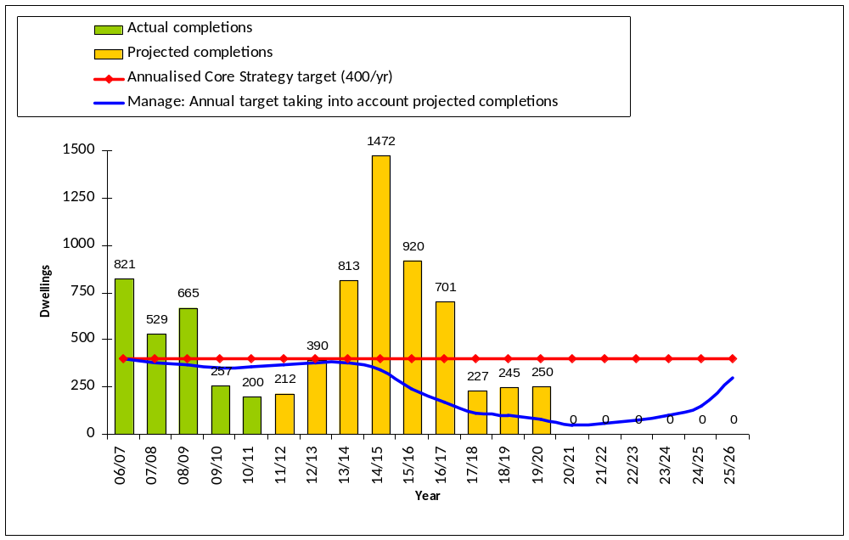

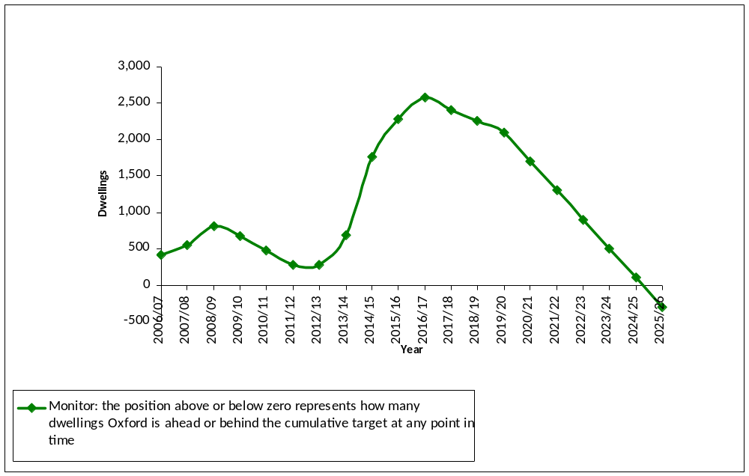
Housing trajectory data against Core Strategy target of 8,000 dwellings from 2006-26
 | 2006/ 07 | 2007/ 08 | 2008/ 09 | 2009/ 10 | 2010/ 11 | 2011/ 12 | 2012/ 13 | 2013/ 14 | 2014/ 15 | 2015/ 16 | 2016/ 17 | 2017/ 18 | 2018/ 19 | 2019/ 20 | 2020/ 21 | 2021/ 22 | 2022/ 23 | 2023/ 24 | 2024/ 25 | 2025/ 26 | Totals
Sites and Housing allocations (deliverable) |  |  |  |  |  |  | 200 | 453 | 765 |  |  |  |  |  |  |  |  |  |  |  | 1418
Sites and Housing allocations (developable) |  |  |  |  |  |  |  | 127 | 125 | 390 | 140 |  |  | 100 |  |  |  |  |  |  | 882
West End AAP sites |  |  |  |  |  |  |  | 50 | 393 | 145 | 145 | 27 |  |  |  |  |  |  |  |  | 760
Core Strategy strategic sites (Barton and Northern Gateway) |  |  |  |  |  |  |  |  | 100 | 375 | 200 | 200 | 175 | 150 |  |  |  |  |  |  | 1200
Former Local Plan sites |  |  |  |  |  | 17 | 40 | 12 |  | 10 |  |  | 70 |  |  |  |  |  |  |  | 149
Employment sites |  |  |  |  |  |  | 10 |  |  |  | 16 |  |  |  |  |  |  |  |  |  | 26
Commitments (large sites) |  |  |  |  |  | 60 | 60 | 63 |  |  |  |  |  |  |  |  |  |  |  |  | 183
Commitments (small sites) |  |  |  |  |  | 80 | 80 | 85 |  |  |  |  |  |  |  |  |  |  |  |  | 245
Sites where permission refused but principle acceptable |  |  |  |  |  |  |  | 13 |  |  |  |  |  |  |  |  |  |  |  |  | 13
Suitable sites pending decision |  |  |  |  |  |  |  |  | 32 |  |  |  |  |  |  |  |  |  |  |  | 32
Basic desktop study |  |  |  |  |  | 55 |  | 10 | 57 |  | 200 |  |  |  |  |  |  |  |  |  | 322
Windfall sites |  |  |  |  |  |  |  |  |  |  |  |  |  |  |  |  |  |  |  |  | 0
Actual completions | 821 | 529 | 665 | 257 | 200 | - | - | - | - | - | - | - | - | - | - | - | - | - | - | - | 2472
Total projected completions | - | - | - | - | - | 212 | 390 | 813 | 1472 | 920 | 701 | 227 | 245 | 250 | 0 | 0 | 0 | 0 | 0 | 0 | 5230
Cumulative completions | 821 | 1350 | 2015 | 2272 | 2472 | 2684 | 3074 | 3887 | 5359 | 6279 | 6980 | 7207 | 7452 | 7702 | 7702 | 7702 | 7702 | 7702 | 7702 | 7702 | 7702
Housing target | 400 | 400 | 400 | 400 | 400 | 400 | 400 | 400 | 400 | 400 | 400 | 400 | 400 | 400 | 400 | 400 | 400 | 400 | 400 | 400 | 8000
Cumulative requirement | 400 | 800 | 1200 | 1600 | 2000 | 2400 | 2800 | 3200 | 3600 | 4000 | 4400 | 4800 | 5200 | 5600 | 6000 | 6400 | 6800 | 7200 | 7600 | 8000 | 8000
Monitor | 421 | 550 | 815 | 672 | 472 | 284 | 274 | 687 | 1759 | 2279 | 2580 | 2407 | 2252 | 2102 | 1702 | 1302 | 902 | 502 | 102 | -298
Manage | 400 | 378 | 369 | 352 | 358 | 369 | 380 | 379 | 343 | 240 | 172 | 113 | 99 | 78 | 50 | 60 | 75 | 99 | 149 | 298 | 298

Appendix 2 – Legal Services advice on status of Inspector’s Report

Adoption of Development Plan Documents – Council’s power to deviate from Inspector’s Report following examination

Pre 15 January 2012
If the Inspector recommended adoption of a development plan document (DPD) as originally prepared the Council could adopt the document as originally prepared (as submitted for examination by that Inspector).

If the Inspector recommended adoption of the DPD with modifications the Council could adopt that document subject to those modifications.

The Council could not otherwise adopt a DPD.

Once a DPD had been submitted for examination it could not be withdrawn unless the Inspector recommended that happened or the Secretary of State directed that it be withdrawn.

15 January 2012 onwards
The Localism Act 2011 made a number of changes to the rules concerning adoption of DPDs including what was stated to be a change from binding Inspector’s Reports to non-binding Inspector’s Reports.

If the Inspector recommends adoption of a development plan document the Council can adopt it as it is or together with modifications that cumulatively do not materially affect the DPD’s policies.

If the Inspector concludes that the DPD should not be adopted but could be made satisfactory by modifications (the Council must ask the Inspector to recommend modifications for this purpose) the Council can adopt that document subject to those recommended modifications. Those modifications are known as “main modifications”. Again the Council can adopt with additional modifications that cumulatively do not materially affect the DPD’s policies (as altered by the main modifications).

The Council can not otherwise adopt a DPD.

The Council can withdraw a DPD at any time.

In substance the changes made by the Localism Act were
- to allow additional non-material modifications
- to allow the Council to withdraw a DPD after submission for examination

The Council remains unable to adopt a DPD other than in a form that is recommended by the Inspector in all material respects.
Appendix 3 – Final version of the Barton AAP
Appendix 4 - Extract of the updated Policies Map
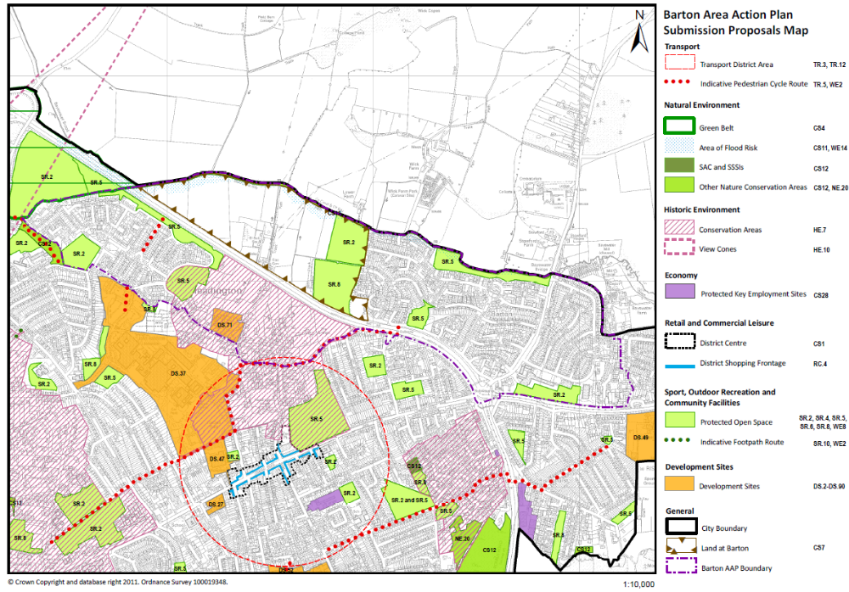
Appendix 5 – Risk Register

Risk ID | Risk |  |  |  |  |  | Corporate Objective | Gross Risk |  | Residual Risk |  | Current Risk |  | Owner | Date Risk Reviewed | Proximity of Risk (Projects/ Contracts Only)
Category-000-Service Area Code | Risk Title | Opportunity/Threat | Risk Description | Risk Cause | Consequence | Date raised | 1 to 6 | I | P | I | P | I | P
 | Legal challenge | Threat | There is a risk of a legal challenge to the adopted plan, the process and timescale for which are summarised in the report. | Aggrieved person(s) who are unhappy with the adopted AAP may decide to exercise their right to apply for a judicial review. In order for a legal challenge to be successful, the High Court would have to be satisfied that the plan is to any extent outside the appropriate power, and/or that the interests of the applicant have been substantially prejudiced by a failure to comply with a procedural requirement. | If successful the High Court would rule that the AAP be quashed, wholly or in part. | 17.12.12 | 2 | 4 | 3 | 4 | 2 | 4 | 2 | Michael Crofton-Briggs

Risk ID | Risk Title | Action Owner | Accept, Contingency, Transfer, Reduce or Avoid | Details of Action | Key Milestone | Milestone Delivery Date | %Action Complete | Date Reviewed
 | Legal challenge | Michael Crofton-Briggs | Reduce

